

Implied Volatility Query Project
Phase I & II
Root Finding Methods Performance Analysis
Dr. Han

Yanzhe Li
Shiyun Liu

Executive Summary
In phase one, dataset was combined and merged from authors’ previous work, which crawled all options information from Yahoo and Nasdaq. In total, the dataset contains 605 unique stock tickers and 24,180 records. Bisection method was used to preliminarily get all European options with a preset tolerance. After filtering, 2,305 records were left*.
Four methods were tested. They are Bisection, Muller-Bisection, Newton, and Halley. In addition, two improved methods were introduced as well, which combined Muller-Bisection in finding initial point for Newton and Halley method.
In phase two, three optimize methods in Scipy package were added. They are brentq, brenth, ridder and newton. Furthermore, multiple initial sigma and initial iteration were tested for all ten methods.
In terms of accuracy and efficiency, Halley method is the best.

Root Finding Methods Performance Analysis Report
- Data Description
  - Data Source
Options data are crawled on Feb 17, 2017 from Nasdaq.com. There are 19,520 records in total.
  - Data Processing
As Black-Scholes model can only suit for European-style options, the original dataset then was trimmed by Bisection method to check if the implied volatility calculated are the same as the actual implied volatility within a preset tolerance. By setting the tolerance as 0.01, there are 2,478 records left.
- Method Introduction
  - Bisection
`
  - Muller-Bisection
Muller bisection is based on the secant method. Rather than constructing a line through two points on the graph of f, Muller’s method is to constructs the parabola through these three points and takes the intersection of the x-axis with the parabola to be the next approximation. Then it compares with bisection’s approximation and choose the better one for the new interval.
  - Newton
Newton method is a way to do the approximation by its tangent line. The x-intercept of the tangent line usually is a better approximation to the function’s than the original guess, such as bisection method.
  - Halley
Halley method is second in the class of Householder’s methods (the first is Newton method). In contrast to newton’s secant approximation or Muller’s intersect approximation, it can be viewed as a linear-over-linear Padé approximation to the function. The rate of convergence is cubic since it uses the second derivative to solve the problem.
  - Hybrid Model
When running Newton and Halley method, sometimes the initial point to start the iteration has a great impact on the performance. Therefore, the new Newton and Halley are conducted by following steps:
    - Use Muller-Bisection to iteration several times
    - Return the Muller-Bisection’s result as the input of the initial point of Newton or Halley method
    - Continue the iteration by using Newton/Halley method
  - Optimized Model
To utilize the root finding modules in scipy package, there are four methods conducted here (introductions from scipy.org):
Brentq: Uses the classic Brent’s method to find a zero of the function f on the sign changing interval [a, b]. Generally considered the best of the root finding routines here. It is a safe version of the secant method that uses inverse quadratic extrapolation. Brent’s method combines root bracketing, interval bisection, and inverse quadratic interpolation.
Brenth: A variation on the classic Brent routine to find a zero of the function f between the intervals [a, b] that uses hyperbolic extrapolation instead of inverse quadratic extrapolation.
Ridder: A method to find a zero of the function f between the arguments a and b. Ridder’s method is faster than bisection, but not generally as fast as the Brent routines.
Newton: The Newton-Raphson method is used if the derivative fprime of func is provided, otherwise the secant method is used. If the second order derivate fprime2 of func is provided, parabolic Halley’s method is used.
- Performance Result
There are seven initial points tested for all methods, which preset as 0.3, 0.5, 0.7, 1.0, 1.5, 1.7, 2.0. For the Muller + Newton/Halley methods, different initial iterations are also tested, which are 10, 100, 500, and 1000 times.
  - Accuracy
Overall speaking, Halley method performs the best in terms of accuracy for different initial points. As shown in above figure, only when sigma₀ = 0.3, the accuracy for Newton method is better than Halley method. For all rest sigma, Halley method has the lowest log difference value. Furthermore, as the larger the initial sigma is, the better its accuracy will be. (Figure 1)
In addition, initial sigma will not affect all secant methods, such as brentq, brenth, ridder, bisections, and Muller’s. Even Muller + Newton/Halley methods are not affected as well. Their accuracies keep the same for all initial points. Moreover, for the scipy package’s module, all three secant methods have the same accuracy.
The hybrid models didn’t improve accuracy at all, comparing with its original method. Regarding the different initial iterations, there aren’t any improvement either. It seems that a few steps (around 10 times) initial iteration is enough for the hybrid method.

  - Efficiency
In terms of efficiency, again, Halley method performs much better than others. Scipy_newton also has a relatively good performance on the running time. Hybrid methods are slowest.
Among all secant methods, brentq and brenth are even better than the Newton method.
Comparing different iterations, in general, the more the iteration is, the slower it will be. This may be because the initial iteration in Muller method is really slow.
- Conclusion
Consider both parts of performance, for calculating the implied volatility, Halley method is the best one among all ten models; second best might be the scipy’s newton.
Appendix
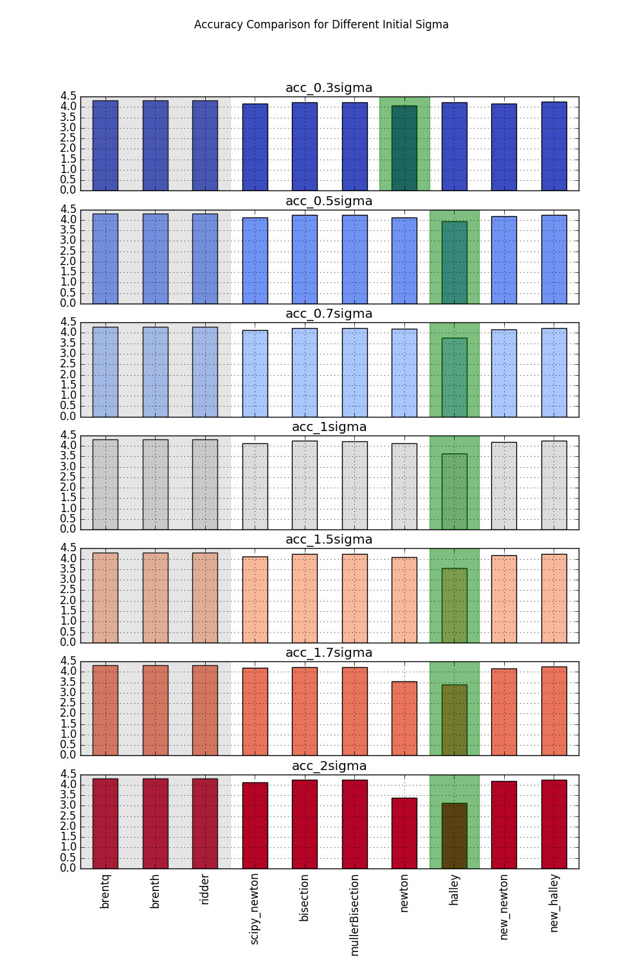
Figure 1. Accuracy Comparison for Different Initial Sigma

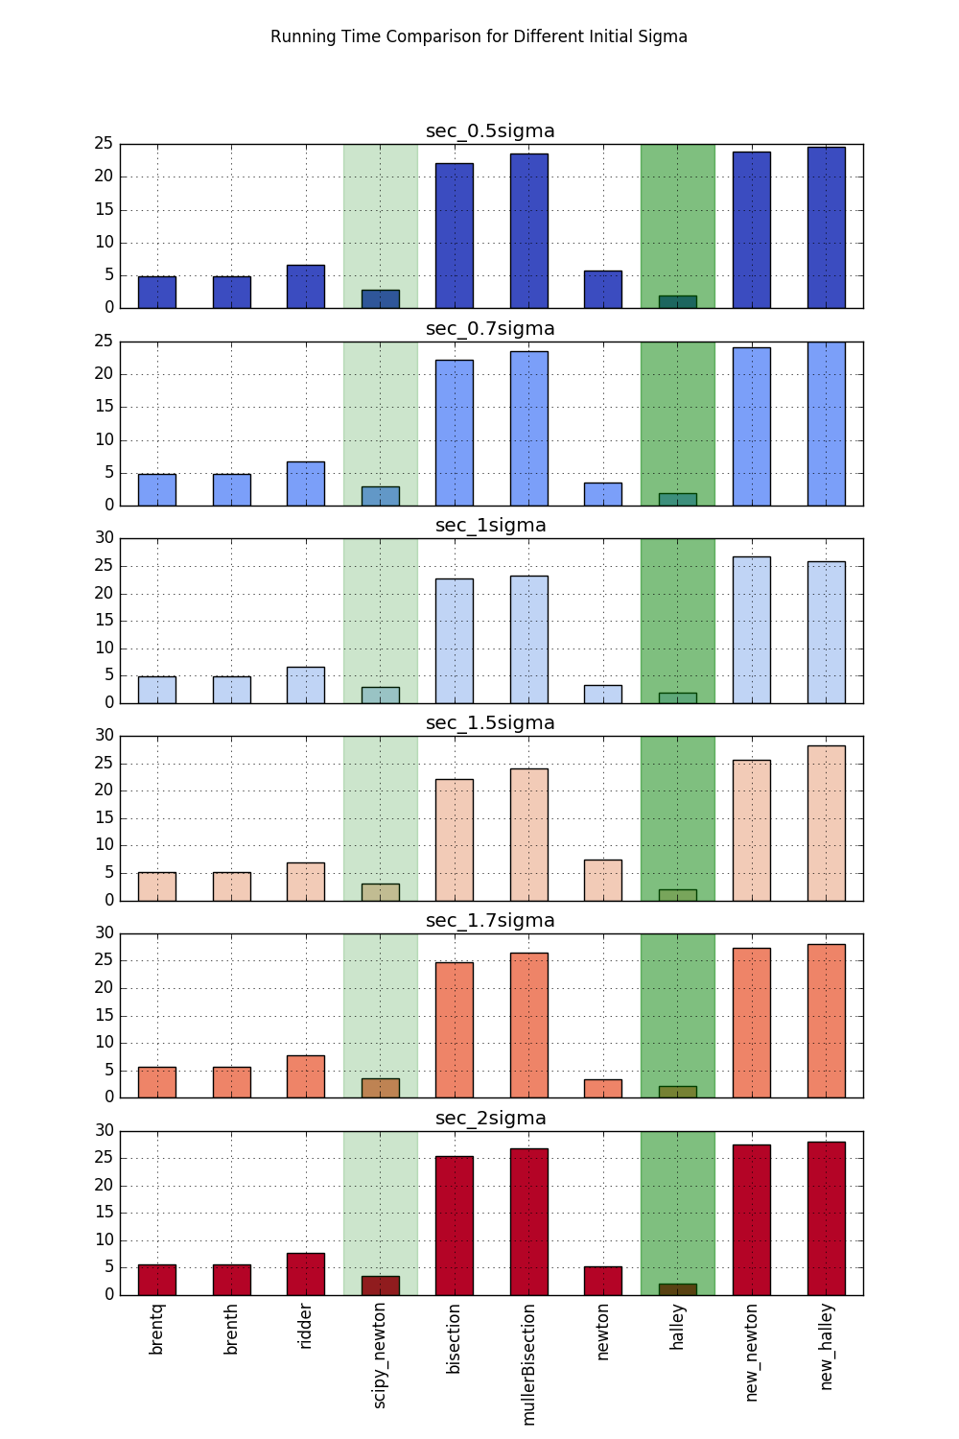
Figure 2. Running Time Comparison for Different Initial Sigma

